**Brand Book for Andrew Joseph Alexander**

About Andrew Joseph Alexander

Andrew Joseph Alexander's site showcases his freelance filmmaking, cinematography, and screenwriting portfolio. The site will contain content in the form of music videos, short films, VFX, highlight films, commercials, photography, and multimedia videos created by Andrew Joseph Alexander. The site targets users who access the site may be other artists, potential collaborators, or even individuals who enjoy music videos, NBA mixes, cinematography, photography, blogs about screenwriting, or filmmaking. Users will be able to easily identify who Andrew is, access content on Andrew's site, and navigate to his social media platforms.

Addressing End User Needs

Andrew's site will be a casual platform that allows end users to view, access, and share creative content and a variety of projects.

Andrew's Unique Background

Andrew Joseph Alexander started making films at the age of 12 and hasn't stopped since. As a graduate of the University of Oregon that is where he discovered his true passion for video editing and cinematography. His portfolio of projects has since evolved into music videos, short films, VFX, highlight films, commercials, photography, and multimedia videos.

Characterizing Andrew's End Users/Target Market

* Fellow artists.
* Individuals seeking collaboration.
* Individuals who enjoy a variety of modern multimedia choices. (Music, Nature, NBA mixes)
* Venue promoters.
* Small businesses seeking alternative creative services. (ex. video editing a project)

Our Primary Message

Andrew Joseph Alexander is a freelance filmmaker, cinematographer, and screenwriter whom creates content in the form of music videos, short films, VFX, highlight films, commercials, photography, and multimedia videos.

User/Visitor Perspectives

* Video Editor
* Music Videos
* Photography
* Writing/Blogging
* NBA mixes

Typography & Consistent Design

Screen Shots:

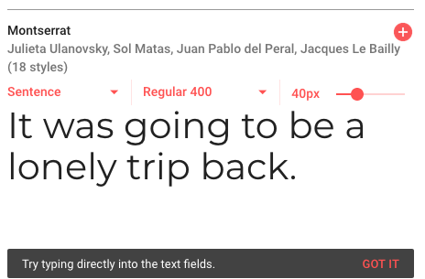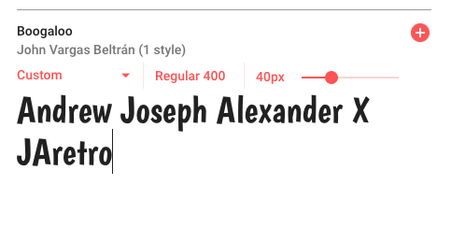

Andrew Joseph Alexander's interface will include Montserrat intended for the main content. Montserrat was selected for its spacing qualities, and Boogaloo for its bold character, artistic style inspired by 1960's LP's and records. Sans-serif fonts were chosen for their clear and readable typeface, which will be appropriate for Andrew's modern brand. The fonts legibility will add to an intuitive & positive user experience.

Brand Image & Color Palette

Screen Shots: 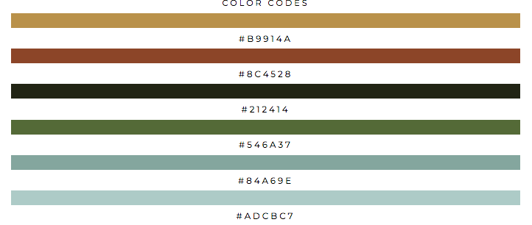

Andrew's sites color palette will create a consistent brand image for the web interface since the end users experience is kept in mind. The colors selected relate to his current logo as well as his geographical location – Pacific Northwest.

Note: Generic black and white colors will be used for backgrounds, text, and more features as necessary. This color palette will contribute a to clean and aesthetically pleasing design, since the colors complement each other regarding contrast.

Visual Styles and Brand Consistency

Images: 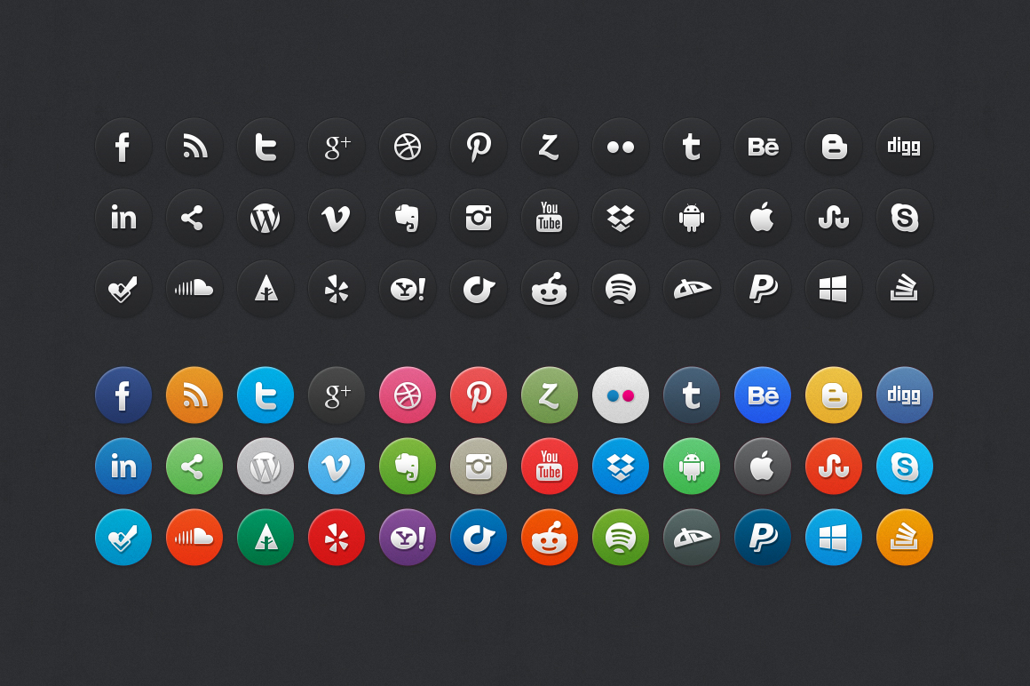

Modern UI icons will be used sparingly to produce visual styles throughout the web sites interface. Andrew specializes in cinematography and photography. (larger scale) These images will be incorporated throughout the web site to showcase content and build upon his brand image.

Inspiration gathered from mood board: <https://pin.it/jcu72f3v7aa3ct>